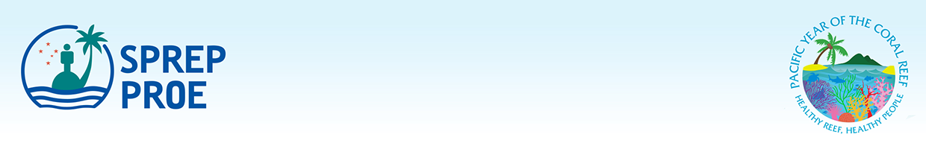

New Zealand Association for Impact Assessment Conference on Climate Change Mitigation Impact Assessment, Technical Visit capacity building and Consultation on the draft SEA Guidelines
25th, 26th and 27th – 28th November 2019, Auckland, New Zealand

Nomination Form

Full Name: ____________________________________________________
(as shown in passport)

Job Title: _____________________________________________________

Organisation: __________________________________________________

Office Address: ________________________________________________

Country: _____________________________________________________________

Phone Number: _________________________________________________

Mobile Number: ________________________________________________

Email: _________________________________________________________

Please email the completed Registration as well as a copy of your passport biodata page by 11th October 2019 to: Jope Davetanivalu: joped@sprep.org and copy faasipal@sprep.org and gregoryb@sprep.org


PO Box 240, Apia, Samoa T +685 21929 F +685 20231 sprep@sprep.org www.sprep.org
A resilient Pacific environment sustaining our livelihoods and natural heritage in harmony with our cultures.

