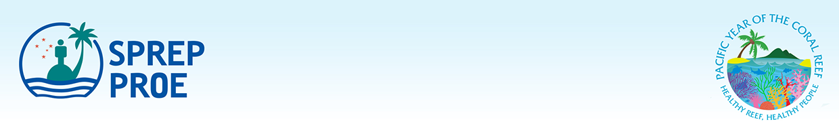

ANNEX 1:

CBD Post 2020 Framework and SDG 14 Targets Workshop
3 – 6 February 2020

Please nominate two participants. Please email the completed nomination form no later than 1 December 2019 to Juney Ward juneyw@sprep.org with a copy to Peter Davies peterd@sprep.org

PARTICIPANT 1
First and Last Name:

Job Title/Designation:

Organization & Department:

Phone No.:

Email Address:

PARTICIPANT 2
First and Last Name:

Job Title/Designation:

Organization & Department:

Phone No.:

Email Address:

