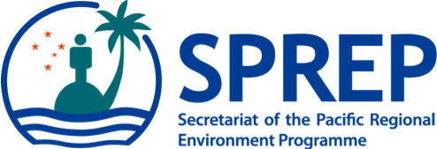
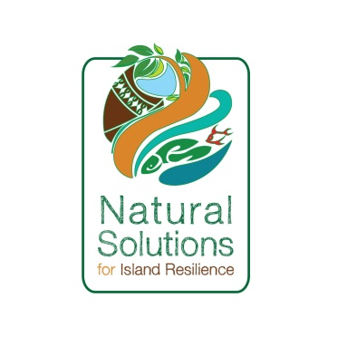
PO Box 240, Apia, Samoa
E: sprep@sprep.org
T: +685 21929
F: +685 20231
W: www.sprep.org
The Pacific environment, sustaining our livelihoods and natural heritage in harmony with our cultures.

Sixteenth meeting of the Noumea Convention
Sixteenth ordinary meeting of the contracting parties to the convention for the protection of the natural resources and environment of the South Pacific Region and related protocols (Noumea Convention), 2 September 2021, Apia, Samoa.

NOMINATION FORM

Country:

Name:
(name displayed in passport)

Job Title:

Organisation/Department:

Address:

Telephone: Fax:

E-mail:

Please email or fax the completed nomination form no later than 17 May 2021 to:

1. Mr. Jope Davetanivalu: joped@sprep.org and
2. Ms. Anastacia Amoa-Stowers: anastacias@sprep.org
or Fax: +885 20231

