SPREP Northern Pacific Office (NPO) Operational Plan and Engagement Strategy
May 2025 - Draft

Table of Contents

Executive Summary 2
1. Rationale for NPO Establishment 3
2. Operational Plan 4
2.1 Key NPO Functions and Activities 4
3. Engagement Strategy 6
3.1. Engagement Strategy 6
3.1.1. Engagement with the SPREP Secretariat 7
3.1.2. Engagement with North Pacific Members and the Working Group 8
3.1.3. Engagement with Partners and Donors 10
4. NPO Staffing 12
5. Budget, Cost Recovery and Resource Mobilization 14
5.1. Budget 14
5.2. Cost Recovery 15
5.3. Resource Mobilization 17
5.3.1. Collaboration in Fundraising 17
5.3.2. Target Donor Groups 17
5.3.3. U.S. Funding Sources 18
6. Monitoring & Evaluation 19
7. Annexes 22
Annex 1: SPREP NP Focal Points and Key Government Contacts (April 2025) 22
Annex 2: Baseline: Major Projects in the North Pacific (April 2025) 26

Executive Summary
The establishment of a SPREP sub-regional office in the North Pacific (NP) has been long planned to address the growing number of projects in the sub-region, the high costs of providing services from SPREP’s Apia headquarters, and the need for more direct engagement with SPREP technical expertise. It will also foster broader partnerships in policy and project development for the sub-region in line with SPREP’s core programmes. Expected benefits of the North Pacific Office (NPO) include increased projects tailored to NP needs, more direct access to technical support, stronger alignment with national and sub-regional priorities, and higher levels of cooperation with current and new donors and partners in the North Pacific. However, there are risks and challenges, such as the need to secure sufficient funding from NP Members and donors to sustain operations, potential competition with other organizations that have an established presence in the region, and possible miscommunications or misunderstandings about the roles and expectations of the SPREP Secretariat, the NPO, and the NP Members.
The NPO operate with a small team and a primarily representational and facilitative role. NPO staff work under the direction of SPREP’s Deputy Director General (DDG) and in collaboration with SPREP Secretariat staff in Apia and Suva to support NP Members. Given the limited initial staffing, most program and project development and technical support will continue to be provided by the SPREP Secretariat. The NPO’s role will expand as additional technical staff are recruited through successful fundraising, allowing the office to assume greater responsibilities over time without reducing the existing level of support from the Secretariat.
The NPO work closely with NP Members to develop and implement its work programme. A Working Group (WG), comprising one representative (ideally the SPREP focal point) from each of the seven NP countries and territories, will partner with NPO and Secretariat staff to guide the implementation of this Operational Plan and subsequent annual work plans. Key elements of the engagement strategy with NP stakeholders include regular in-country visits by NPO staff (at least twice annually per member, funding permitting), monthly check-in calls with focal points, quarterly activity reports, an annual review meeting (virtual or in-person) involving the SPREP Director General (DG), DDG, Secretariat and NPO staff with the WG, and side meetings at regional events. The NPO will initially be staffed by a Manager and a Technical & Liaison Support Officer. As budget and needs grow, additional positions (e.g. a second technical officer, finance/administration support, and office support staff) will be added to strengthen the office’s capacity.
SPREP has committed US$100,000 in core funding to launch the NPO. Micronesian Leaders have agreed in principle to provide supplementary financial support; to date, the Republic of the Marshall Islands has contributed funding and is hosting the office space. For the NPO to achieve full operational capacity in 2026, a total of about US$206,000 is requested through national budgets or projects from the seven North Pacific Members (approximately US$30,000 per member) to complement SPREP’s core funding. Annual member contributions are expected to increase in subsequent years as the NPO expands its activities and staffing, though successful donor fundraising will offset and reduce the required member contributions. In addition to member contributions, the NPO will actively seek project funding from traditional SPREP donors, and for the three Compact of Free Association countries (Palau, FSM, RMI) as well as Guam and the Commonwealth of the Northern Mariana Islands (CNMI), the NPO will pursue support where possible from relevant U.S. Government agencies as part of its resource mobilization strategy.
The NPO will adhere to standard SPREP monitoring and evaluation (M&E) policies and procedures. Key performance indicators will include growth in the number of projects implemented in the North Pacific (baseline data on ongoing projects as of April 2025 is compiled in Annex 2), progress against the NPO work plan, feedback from NP stakeholders (e.g. via Working Group meetings), and an independent evaluation after three years of operation (anticipated in late 2026) if resources permit. For new sub-regional projects where the NPO takes a leading role, project-specific M&E plans will be developed in line with SPREP and donor requirements.
- Rationale for NPO Establishment
SPREP’s Northern member countries and territories have long advocated for a dedicated sub-regional presence in Micronesia. The rationale for establishing the NPO includes the significant increase in projects and activities in the North Pacific, the high costs (especially travel costs) of supporting these activities from SPREP’s Samoa headquarters, and the need for more direct communication and engagement between SPREP’s technical experts and its Northern Members. An NPO based in the region will also enable stronger partnerships and coordination in policy development and project implementation, aligning SPREP’s work more closely with national and sub-regional priorities.
The NPO is expected to provide several added-value benefits to SPREP’s North Pacific Members, including:
- Facilitating strategic partnerships and networking among NP Members, regional institutions, and other stakeholders.
- Supporting resource mobilization and project development, helping NP Members and SPREP secure funding for environmental and climate initiatives.
- Enhancing SPREP’s engagement in the North Pacific, allowing closer partnership with NP Members through a local presence.
- Achieving greater alignment of SPREP programmes and projects with North Pacific national and sub-regional priorities, ensuring SPREP’s work is responsive to local needs.
- Improving access to technical assistance and policy support by positioning SPREP expertise closer to NP Members for quicker and more tailored advisory services.
These benefits reinforce SPREP’s core mandate to support Pacific Island Countries and Territories on environmental management and sustainable development. The NPO will serve as a bridge to deliver SPREP’s strategic priority areas (including Climate Change Resilience; Environmental Governance; Biodiversity Conservation; Waste Management and Pollution Control) more effectively in the North Pacific.
- Operational Plan

2.1 Key NPO Functions and Activities
In fulfilling SPREP’s mandate in the North Pacific, the NPO will mirror SPREP’s existing governance and management systems and follow policies and processes set by the SPREP Meeting and Council. Initially operating under the supervision of the SPREP DDG, the NPO will work in close partnership with North Pacific Members, donors and partners, and SPREP’s technical and management teams. The core functions and activities of the NPO include:
- Project and programme design support: Assisting NP Members and SPREP in the identification, design, and development of environmental projects and programmes.
- Facilitating access to funding: Enhancing accessibility to international funding sources such as the Green Climate Fund (GCF), Global Environment Facility (GEF), Adaptation Fund, and other donors or foundations.
- Project implementation support: Supporting NP Members in implementing and monitoring SPREP-supported national and sub-regional programmes, including assistance with implementing Country and Territory Strategic Partnership Frameworks.
- Advisory support on environmental commitments: Providing advice and support to NP Members on Multilateral Environmental Agreements (MEAs) and conventions (e.g. the UN Convention on Biological Diversity, UNCBD; the UN Framework Convention on Climate Change, UNFCCC) and other environmental issues.
- Capacity building: Organizing or facilitating training and capacity-building initiatives to strengthen environmental management capabilities in NP Member governments and organizations.
- Sub-regional and national strategy development: Working with NP Members to develop sub-regional and national environmental strategies and frameworks that complement SPREP’s regional Strategic Plan and other regional thematic strategies (e.g. Cleaner Pacific Strategy, Framework for Nature Conservation and Protected Areas).
- Support SOE and MEAs reporting: Working with NP members on environmental data collection and storage, plus monitoring and reporting, to support State of Environment and MEAs reporting.
- Liaison with SPREP headquarters: Linking the sub-region to SPREP’s Apia (and Suva) offices by improving communication and consultation between Northern Members and SPREP’s programme and technical staff.
- Coordination with CROP agencies and partners: Connecting NP Members to other Council of Regional Organisations of the Pacific (CROP) agencies and potential partners or donors in the region and beyond, to foster collaborative efforts.
- Participation in regional meetings: Representing the North Pacific in sub-regional, regional, and international meetings on environmental issues, ensuring NP interests are voiced.
- Support to Micronesian initiatives: Assisting regional initiatives such as the Micronesia Challenge and other collaborative environmental efforts in Micronesia.
- Facilitating regional representation: Supporting NP Member participation in broader Pacific regional and global environmental forums and conferences.
- Backstopping SPREP projects: Providing on-the-ground backstopping for all SPREP projects and core programme areas in NP countries and territories, including help with project monitoring, evaluation, and reporting.
These activities will be guided by the NPO’s annual Work Plan, which will be informed by Country and Territory Strategic Partnership Frameworks and other agreed sub-regional or national environmental plans and priorities. Major decisions regarding NPO operations will be made by SPREP in consultation with the NP Working Group (described below), while NPO staff will manage day-to-day implementation.
- Engagement Strategy
  - Engagement Strategy
The NPO’s engagement strategy outlines how it will interact with different stakeholders to maximize its effectiveness. Key stakeholder groups include: (1) the SPREP Secretariat (headquarters and Fiji offices), (2) the North Pacific Members and the NPO Working Group, and at least (3) other partners and donors active in the North Pacific. The NPO serves as a bridge between SPREP’s central Secretariat and the North Pacific member countries, facilitating two-way communication and support. In this role, the NPO represents SPREP in the North Pacific and conveys member priorities back to SPREP HQ, ensuring that Northern member needs are understood and addressed, see Figure 1.
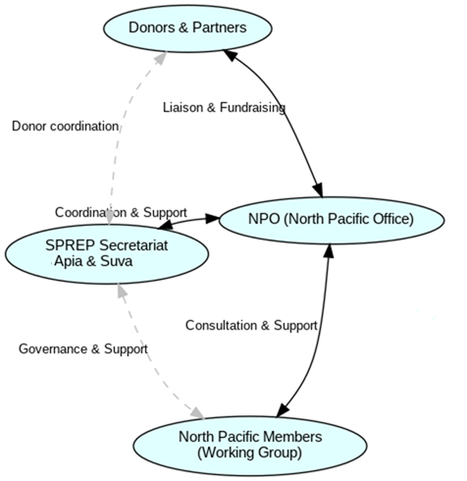
Figure 1 Stakeholder engagement flows among the SPREP Secretariat, North Pacific Members, the NPO, and donors/partners.
The sections below detail the approach for each group.
    - Engagement with the SPREP Secretariat
As highlighted by the SPREP Director General in discussions with NP Members at the 31st SPREP Meeting, one of the NPO’s primary initial roles is representational – representing SPREP in the North Pacific and, conversely, representing NP Member interests to the SPREP Secretariat. The NPO will serve as a conduit for communication, ensuring that the high level of support NP Members receive from the Secretariat is maintained and enhanced. In the near to mid-term, most technical expertise and fundraising support will still come from the main Secretariat offices (since approximately 97% of SPREP staff are based in Apia or Suva), but the NPO will facilitate and coordinate this support on the ground. Over time, as sub-regional programmes and projects grow, the NPO can expand its own technical staff to take on more direct implementation roles.
To maintain close collaboration, the NPO will implement the following engagement measures with the SPREP Secretariat staff and management:
- Monthly coordination calls with Project Managers overseeing activities in NP countries/territories. These brief check-ins will review current project progress, upcoming activities, challenges, and how the NPO can facilitate outputs and outcomes in the NP context.
- Monthly calls with Technical Advisers (SPREP programme and department technical staff) to discuss any project elements or Member needs that may require NPO assistance, to coordinate pipeline project development, and to consider new project ideas and funding opportunities for the North Pacific.
- Ad hoc consultations: Regular discussions as needs arise to address urgent issues or opportunities, and to evaluate Country and Territory Strategic Partnership Framework implementation and discuss monitoring and evaluation of NPO work. Secretariat and NPO staff will keep open lines of communication outside of scheduled calls.
- Email coordination: Ensuring that Secretariat and NPO staff copy each other on communications with NP Members and partners. This transparency keeps everyone informed and enables the NPO to stay up to date on all activities in the sub-region.
- Representation at meetings and missions: When SPREP Project Managers, Technical Advisers, or other staff cannot travel to NP countries due to budget or scheduling constraints, NPO staff will represent them at important meetings or undertake support missions on their behalf. In such cases, project or programme budgets (or core funds) will cover the NPO staff travel costs. To make these missions effective, the process will include: (1) thorough pre-trip consultations with the relevant SPREP staff to ensure NPO representatives are fully briefed; (2) on-going communication during the mission for any necessary guidance or decisions; and (3) post-mission debriefs and follow-up actions with both the Secretariat and NP stakeholders (including mission reports and next steps).
- Project development coordination: Monthly discussions with SPREP’s Project Management Unit (PMU) to review projects under development and explore new project concepts, ensuring NP priorities are considered in SPREP’s broader project pipeline.
- Management oversight: Monthly meetings with the SPREP DDG to update on NPO activities, highlight any strategic or high-level issues arising from NP engagements, and to receive guidance.
- Communications support: Providing NP success stories, news, and photographs to the SPREP Communications Team for publication on SPREP’s website and social media, raising the profile of NP initiatives.
- In-country visits by Secretariat staff: Meeting with Apia- or Suva-based SPREP staff when they travel to NP countries to discuss current projects, pipeline ideas, and future needs. The NPO will help organize and accompany these visits to maximize their impact.
- Side meetings at regional events: Taking advantage of gatherings (e.g. the annual SPREP Meeting or other regional conferences) to hold side meetings between NPO and Secretariat staff to strategize on NP project pipelines and emerging opportunities.
- Quarterly NPO activity reports: Preparing a quarterly report summarizing NPO activities, outputs, outcomes achieved, and challenges. These reports will be shared with SPREP senior management and relevant staff to keep the Secretariat fully informed and engaged in NPO progress.
- Additional communication: Frequent phone calls or emails as necessary to address issues in real time, and a practice of mutual inclusion on relevant communications (as noted above) to maintain cohesion between NPO and headquarters.
    - Engagement with North Pacific Members and the Working Group
Effective engagement with the NP Member countries and territories is central to the NPO’s mission. The North Pacific Working Group (WG) will be the primary mechanism for Member coordination. The WG will consist of one representative from each NP jurisdiction (the SPREP Operational or Political Focal Point). This group will steer and guide NPO programmes and activities, ensuring they meet Members’ needs. The WG will review and endorse this NPO Operational Plan and subsequent revisions, as well as annual NPO Work Plans. For new WG members, SPREP provide an induction / orientation programme so that focal points are fully aware of and understand their roles and responsibilities. There is also an opportunity set up a focal point mentoring programme.
The NPO will engage NP Members and the Working Group in the following ways:
- Joint planning and M&E: The Working Group will play key roles in developing and approving the NPO’s Business/Operational Plan and Work Plans, and in monitoring and evaluating the implementation of these plans. Their guidance will ensure the NPO’s work remains aligned with national priorities.
- Regular country visits: Subject to funding availability, NPO staff (the Manager, Technical & Liaison Officer, and other technical officers as hired) will aim to visit each NP Member country/territory at least twice per year. These in-country consultations will be used for planning, stakeholder meetings, technical support, and review of project progress. (Key government agencies to be consulted during these visits are listed in Annex 1.) In addition, during each visit the NPO will meet with government agencies implementing SPREP projects to offer support and strengthen collaboration.
- Monthly check-in calls: NPO staff will hold monthly telephone or virtual check-ins with each Member’s SPREP focal point (or a designated representative). These informal updates will maintain communication, allow sharing of recent developments, and flag any issues or support needs in real time.
- Pre-SPREP meeting consultations: Prior to major SPREP Meetings or regional gatherings, the NPO will organize consultations (virtually if not in person) with NP Members to help prepare and coordinate positions, ensuring effective participation and that NP priorities are well represented.
- Side meetings at regional events: The NPO will facilitate side meetings with North Pacific delegations at Pacific-wide or sub-regional events (whether organized by SPREP or other agencies) to discuss issues, share knowledge, and reinforce partnerships among NP Members.
- Quarterly reporting: As noted, the NPO will provide quarterly reports detailing activities, outcomes, and challenges. These reports will be shared with NP Member focal points and the Working Group to keep all parties informed and involved in oversight.
- Annual NPO review meeting: Each year, the NPO will convene a meeting with the Working Group and SPREP senior management to review NPO performance and plan. This will occur as a side meeting to the SPREP Meeting if timing and logistics permit, or otherwise via a dedicated virtual meeting in years when no SPREP Meeting is held. The SPREP DG, DDG, other relevant Secretariat staff, NPO staff, and all Working Group members will attend. This forum allows high-level review, Member feedback, and strategic guidance for the NPO.
- Thematic virtual meetings: As needed, the NPO may organize additional virtual meetings or webinars on specific topics of interest to NP Members (for example, discussing a particular funding opportunity or technical issue) to ensure ongoing engagement outside the regular schedule.
- Continuous communication: Other phone calls or email communications will be used as necessary to respond to emerging needs. NPO staff will remain accessible to NP Members, and likewise NP focal points are encouraged to reach out to the NPO whenever needed.
Through these mechanisms, NP Members will have a strong voice in guiding the NPO’s work, and the NPO will remain responsive and accountable to its members.
    - Engagement with Partners and Donors
There are numerous regional, sub-regional, and national partner organizations active or present in the North Pacific. The NPO will engage with these partners to coordinate efforts, avoid duplication, and identify opportunities for collaboration and resource sharing.
Key sub-regional partners/agencies that the NPO will work with include, but are not limited to:
- Micronesia Challenge Secretariat
- Micronesia Conservation Trust
- The Nature Conservancy
- Conservation International
- Island Conservation
- SPC (Pacific Community) North Pacific sub-regional office
- United Nations Resident Coordinator’s Office for Micronesia
- UN agency representatives in Micronesian countries (e.g. UNDP, UNEP, FAO, etc.)
- UNDP Micronesia Sub-Regional Office
- World Bank North Pacific Office
- Asian Development Bank (ADB) North Pacific Office
At the national level, important non-governmental and civil society partners include:
- Palau Conservation Society
- The four FSM State conservation societies
- Marshall Islands Conservation Society
- Women United Together in the Marshall Islands (WUTMI)
- Kiribati Association of Non-Governmental Organisations (KANGO)
- Nauru Island Association of NGOs
- (Additional relevant organizations may be engaged as identified.)
The NPO will collaborate with these organizations similarly to how it engages NP governments: scheduling meetings during country visits, maintaining communication via calls or emails, and coordinating side meetings at regional events. By building a strong network among government and non-government partners, the NPO will promote a more cohesive and effective environmental effort across the North Pacific.
For donor and funding agency engagement, the NPO will coordinate closely with SPREP’s existing donor liaison efforts. Traditional donors that have supported SPREP projects (and will be critical for NPO fundraising) include: the Green Climate Fund (GCF), the Adaptation Fund, the Global Environment Facility (GEF), the European Union (EDF funding), the Australian Department of Foreign Affairs and Trade (DFAT), New Zealand Ministry of Foreign Affairs and Trade (MFAT), USAID (noting that USAID funds may not be available to Kiribati and Nauru nor the Compact countries or U.S. territories), the Government of Canada, the UK’s Foreign, Commonwealth & Development Office (formerly DFID), the Japan International Cooperation Agency (JICA), the Agence Française de Développement (AFD), the World Bank, the Asian Development Bank, UN agencies (UNEP, UNDP, FAO, etc.), and various private foundations (e.g. MacArthur Foundation, Packard Foundation). The SPREP Secretariat will generally take the lead in communicating with the headquarters or regional offices of these donors, while the NPO will focus on engaging their North Pacific regional or country offices, including in-person visits during travel, regular email/phone communication, and meetings at sub-regional events.
Additionally, for the three Compact of Free Association nations (FSM, Palau, RMI) and the U.S. territories (Guam and CNMI), there are opportunities to seek support from U.S. Government agencies. The NPO will take the lead in exploring funding and technical assistance from entities such as the U.S. Environmental Protection Agency (EPA), the Department of the Interior (including the U.S. Fish & Wildlife Service, U.S. Geological Survey, Bureau of Ocean Energy Management), and the National Oceanic and Atmospheric Administration (NOAA, including the National Weather Service). By leveraging relationships with these agencies, which have mandates or interest in the North Pacific, the NPO aims to tap additional resources for environmental projects and capacity building in the region.
In all partner and donor interactions, the engagement strategy will emphasize collaboration and mutual support. For partners implementing projects funded through SPREP, their primary communication will continue to be with the designated SPREP project managers. However, to keep the NPO fully informed and able to assist if needed, SPREP will request that partners copy the NPO on relevant communications. Conversely, the NPO will copy the appropriate SPREP staff on its communications with any project implementing agencies in the North Pacific. This ensures transparency and a unified SPREP approach.
By actively engaging with the broad network of governmental, non-governmental, and donor partners, the NPO will position itself as a central hub for environmental collaboration in the North Pacific, enhancing the impact of all stakeholders’ efforts.
- NPO Staffing
(“People”) Current and Planned NPO Staffing: The North Pacific Office will operate under the general direction of the SPREP DDG. As of September 2024, the staffing is as follows:
- North Pacific Office Manager: Filled (currently contracted Mr. Semi Qamese). Responsible for overall management of the NPO, representation, and coordination of services to NP Members.
- Technical Expert and Liaison Officer: Filled (currently Mr. Kilom Ishiguro). Serves as a technical adviser and primary liaison with NP Members and partners, assisting the Manager in programme delivery.
- Technical Officer: Vacant (to be recruited when needed). SPREP’s Invasive Species Programme supported a Technical Officer position located in the Marshall Islands, based on funding availability. In the future, the specialization of this Technical Officer (or additional technical officers) will be determined by NP Members’ needs and the focus of projects for which funding is secured.
- Finance/Administration Officer: Vacant (to be recruited when needed). This role will handle financial management, reporting, and administrative support for the NPO. Recruitment is anticipated once NPO operations and budget size grow (potentially from 2026/27 onward).
- Office Support Staff: Vacant (to be recruited when needed). An office assistant/administrative support position will be added when the volume of work and number of staff justify additional logistical and clerical support.
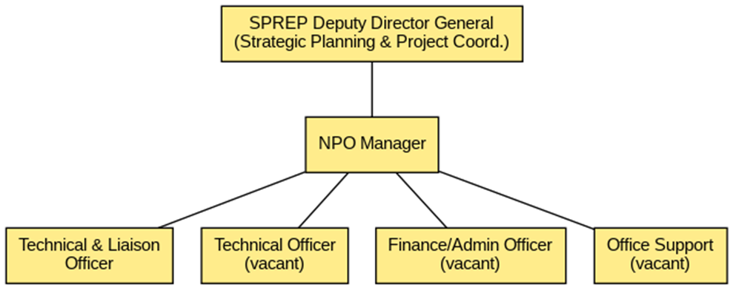
Figure 2 Organizational structure of SPREP’s Northern Pacific Office (NPO), showing its position under SPREP Headquarters and initial staffing. This phased staffing approach for NPO will start small and then scale up as resources permit, allowing it to gradually take on more technical and administrative responsibilities without reducing support from the main Secretariat.
In addition to the above, Figure 2, other positions may be created as the NPO evolves. For example, if significant new projects are obtained, project-specific coordinators or technical specialists (Project Management Unit) could be based at the NPO (including the possibility of placing staff in NP countries or territories other than the Marshall Islands to extend NPO’s reach). The expansion of the team will depend on demonstrated needs and availability of funds.
- Budget, Cost Recovery and Resource Mobilization
  - Budget
2025 Budget: Table 1 below outlines the budget for 2025, which assumes the NPO operates with the two-core staff (Manager and Technical Liaison Officer) and no additional hires in the first year. This “ramp-up” budget covers salaries, basic operations, travel, and setup costs.
Table 1 Proposed budget 2025
Line Item | 2025 Amount (US$)
Office Manager | $145,216
Technical Expert & Liaison Officer | $55,406
Operating Costs (office rent, utilities, etc.) | $15,000
Travel for NPO staff to SPREP HQ (2 trips) | $10,000
Travel for NPO staff to NP Members (see note) | $28,000
Office Equipment | $5,000
Office Supplies | $3,000
Sub-Total | $261,622
5% Contingency | $13,081
Total (2025) | $274,703
– Funded by SPREP Core | $100,000
– Required from NP Members or projects | $174,703
– Indicative per Member (÷7) or projects | $24,958
Note: The travel budget for intra-North Pacific visits is calculated with cost-saving in mind by combining multiple country visits into single trips. For example, one trip would cover both Nauru and Kiribati in one two-week itinerary, and another trip would cover Palau, Guam, CNMI, and Pohnpei (FSM) in a two-week circuit, thereby reducing overall flight expenditures.
Full Operational Budget: Table 2 presents the estimated annual budget for the NPO at full capacity (potentially from 2026/27 onward), when key additional staff are in place and regular activities are expanded. This includes a third technical position and administrative support.
Table 2 Estimated annual budget at full capacity for 2026/27
Item | Estimated Annual US$
Office Manager (Grade EPAI) | $145,216
Technical Expert & Liaison Officer (EPAI) | $55,406
Technical Officer (EPAI) | $55,406
Finance/Admin Officer (EPAL) | $47,156
Operating Costs | $42,500
Air Travel & DSA – NP Members (2 visits/year by 3 staff) | $69,500
Air Travel & DSA – SPREP HQ (1 visit/year by 3 staff) | $15,000
Office Supplies & Equipment & Office operations | $19,500
Communication & IT | $3,000
Sub-Total | $452,684
5% Contingency | $22,635
Total (Full Ops) | $475,318
– Funded by SPREP Core | $270,000
– Balance to be funded by NP Members or projects | $205,318
– Indicative per Member (÷7) or projects | $29,330
(EPAI and EPAL refer to SPREP staff salary band levels. DSA refers to daily subsistence allowance for travel.)

Under the full operations scenario, the total annual budget is approximately $475k. After SPREP’s core contribution of $270k, about $205k would need to be secured through other means, equating to roughly $29k per NP Member if it were divided evenly or from new project funding. The intent, however, is that increased project funding (and possibly other income) will reduce the direct contributions required from Members over time.
  - Cost Recovery
The NPO’s cost recovery plan has four main components to ensure its financial sustainability:
- SPREP Core Funding: An annual allocation from SPREP’s core funds. SPREP’s core budget is financed by voluntary member contributions, project management fees, programme funding to core, and other income (interest, rent, etc.). This core support is crucial for flexibility, allowing the NPO to seize new opportunities and respond to emerging environmental, political, social, or economic challenges in the sub-region. SPREP will periodically review its overall core funding levels and assess the possibility of increasing the NPO’s core allocation as feasible, recognizing the organization-wide need for more core resources.
- North Pacific Member Contributions: Additional financial support from NP Member governments, outside of their regular SPREP member contributions, dedicated specifically to NPO operations. As noted in the NPO’s development history, the Micronesian Leaders committed to such support. To date, only RMI has contributed (and provided office space). The projected ask is ~$25k per Member for 2025, potentially increasing to ~$30k at full operation. Members may provide this from general budgets or include it in project funding proposals developed with SPREP (for example, via readiness funding from climate finance sources). Any amount that Members can contribute will bolster the NPO’s effectiveness and longevity, even if the full target amount isn’t met initially.
- Project Funding for NPO Activities: Project-generated funds raised by the NPO and NP Members including SPREP's pipeline for projects to benefit the NP countries will be used where possible to cover NPO costs. New environmental projects that include activities in NP countries can allocate budget lines for NPO staff time, travel, or other support. In practice, as the NPO helps develop and secure projects for the North Pacific, those project budgets can fund NPO involvement in implementation (essentially embedding some operational costs within project funding). This not only recovers costs but also integrates the NPO into project delivery.
- Cost-sharing from SPREP programmes: Existing SPREP programme and project managers (based in Apia or Suva) can allocate funding for NPO support when it benefits their projects. For example, if NPO staff attend a meeting or carry out field support on behalf of a project, the project’s budget can cover the travel cost or a portion of the staff’s time. In some cases, NPO staff might undertake tasks that would otherwise require an external consultant, allowing project funds to be reallocated to cover NPO staff salary for that period. This arrangement can be more efficient given the higher travel costs from the South Pacific to the North Pacific. By having NPO staff step in, projects save on travel time and expenses, while the NPO recovers some of its operational costs through these contributions.
By leveraging these four avenues, the NPO aims to diversify its funding and reduce reliance on any single source. Core funding and member contributions provide a stable foundation, while project-linked funding and cost-sharing maximize the use of available donor resources to support the office.
  - Resource Mobilization
A proactive Resource Mobilization Strategy is essential for the NPO to grow and fulfill its mandate. There is strong potential to raise funds for North Pacific initiatives, especially given increasing international attention on the Pacific (including heightened geopolitical interest leading to greater aid investment).
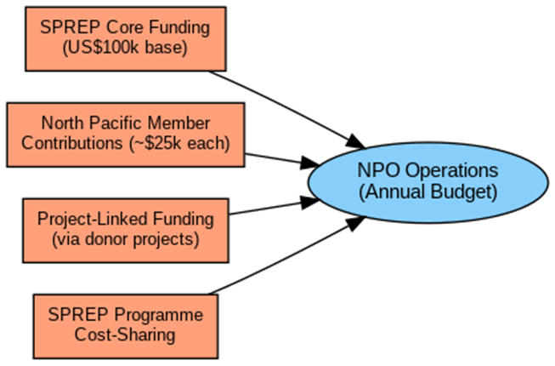
Figure 3 Funding streams supporting the NPO’s operations, illustrating core support, member contributions, and project-linked funding
    - Collaboration in Fundraising
Effective fundraising for the NPO will require a partnership approach involving NPO staff, SPREP Secretariat staff in Apia and Suva, and NP Member governments. Fundraising will be treated as a standing priority in all NPO engagement activities. For instance, during Member engagement and Working Group meetings, identifying funding needs and opportunities will be on the agenda; during engagements with partners and donors, the NPO will consistently promote the North Pacific’s environmental priorities and propose ideas for funding support.
    - Target Donor Groups
As outlined, one focus area will be on donors that have historically supported SPREP at the regional level. The NPO will dovetail with SPREP’s efforts by ensuring North Pacific priorities are included in proposals to the GCF, GEF, Adaptation Fund, EU, and other multilateral mechanisms. Traditional bilateral donors like Australia (DFAT) and New Zealand (MFAT) will continue to be engaged, as will Japan (JICA), France (AFD), Canada, the UK (FCDO), and United Nations programs. Foundations and philanthropic organizations with interest in environmental conservation will also be pursued for targeted project funding.
For these established donors, SPREP’s central offices will lead high-level communications and proposal submissions, while the NPO will complement by maintaining relationships with any local offices or missions in the North Pacific (for example, the EU Delegation or JICA offices in Micronesia). The NPO, by being on the ground, can help tailor proposals to local context and coordinate donor visits or consultations in NP countries.
    - U.S. Funding Sources
Given the unique political status of some North Pacific entities, the NPO will also seek opportunities with U.S. Government funding sources. The Compact nations (FSM, RMI, Palau) and the territories of Guam and CNMI have access to certain U.S. federal grant programs. NPO staff will explore environmental grant programs or technical assistance from agencies such as the EPA, NOAA, and Department of the Interior. This includes tapping into initiatives for climate resilience, biodiversity, and sustainable development that the U.S. may offer in the Pacific. The NPO will take the lead in these discussions, coordinating closely with the respective national governments to align with their Compact funding strategies. See figure 4 for project development and implementation cycle.
In implementing the resource mobilization strategy, the NPO will ensure that fundraising efforts are closely aligned with SPREP’s overall strategic priorities and the specific needs of North Pacific Members. Regular updates on funding opportunities and proposal progress will be shared with the Working Group and NP governments, so that everyone remains informed and can contribute support or political advocacy when needed. Over time, successful resource mobilization will not only finance NPO operations but also bring new projects and benefits to the North Pacific, thereby reinforcing the value of having a dedicated sub-regional office.
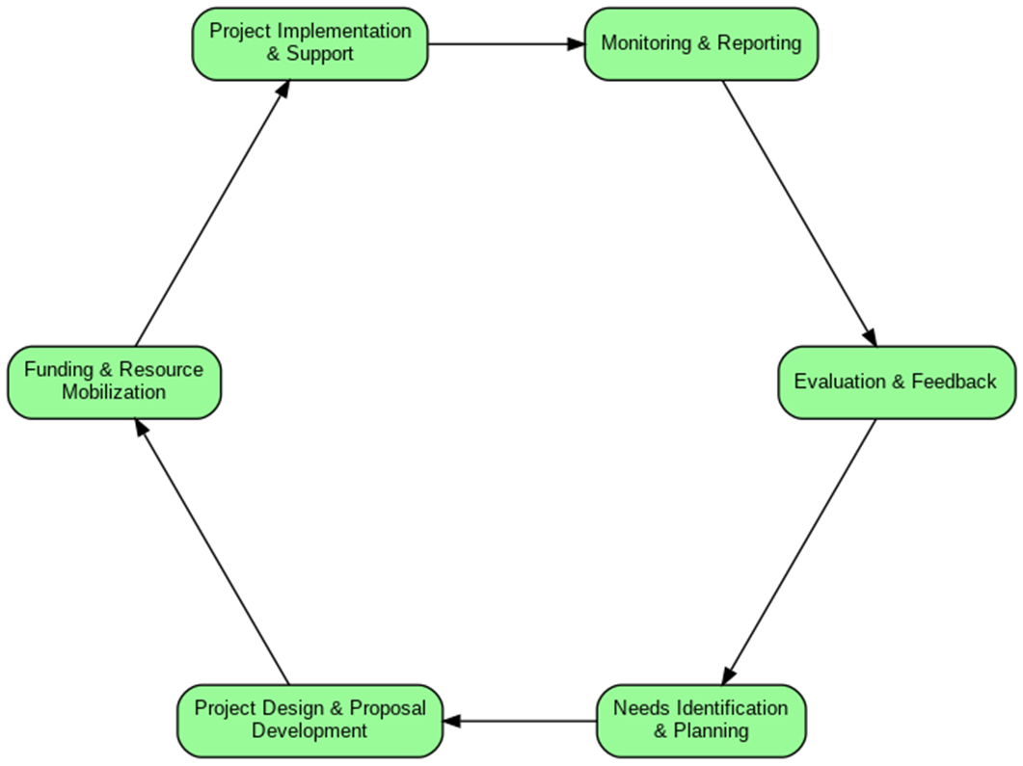
Figure 4 Project development and implementation cycle, highlighting the NPO’s facilitative role at each stage
- Monitoring & Evaluation
The NPO will follow standard SPREP monitoring and evaluation policies and practices to track its performance and the outcomes of its work.
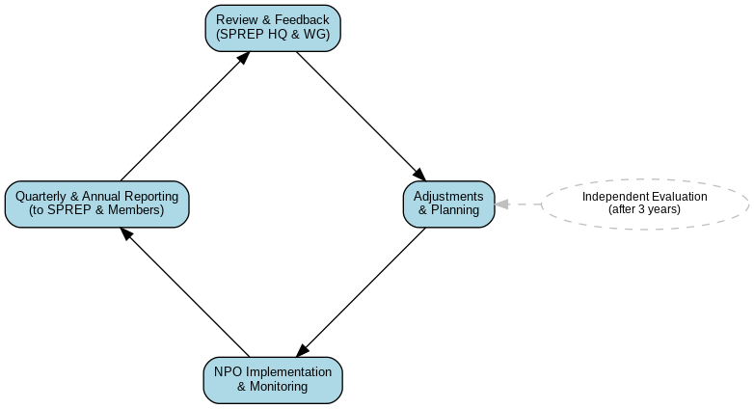
Figure 5 Monitoring and evaluation (M&E) feedback loops connecting the NPO, SPREP Headquarters, and North Pacific members

Monitoring and evaluation will occur at multiple levels:
- Operational Plan and Work Plans: The implementation of this NPO Operational Plan and subsequent annual Work Plans will be regularly monitored by NPO staff, the SPREP Secretariat, and the Working Group. Progress will be reviewed in quarterly reports and annually at the NPO review meeting. The Working Group will have the opportunity to provide feedback and assess progress at the annual meetings with the Secretariat and NPO (as described in the engagement strategy). They will review whether planned activities have been completed and whether desired outputs and outcomes are being achieved. Adjustments to strategies or activities can be made based on this feedback.
- Project and Programme Implementation: An expected benefit of establishing the NPO is an increase in the number and effectiveness of projects in the North Pacific. Annex 2 of this document list the projects being implemented in the North Pacific as of April 2025, which will serve as a baseline indicator. The NPO will monitor growth in project numbers and funding in the sub-region over time. Additionally, for any specific sub-regional projects where the NPO takes a leading role in management, the NPO will develop and execute project-specific M&E plans. These plans will align with SPREP’s overall M&E framework and comply with any donor-specific requirements (such as logical frameworks, indicator tracking, and reporting schedules).
- Stakeholder Feedback: Qualitative feedback from NP Members, partners, and donors will be an important part of evaluation. Through forums like the Working Group and regular consultations, the NPO will gather feedback on its responsiveness, the value it adds, and any areas for improvement. Positive feedback and successful facilitation (e.g., resolving an issue or unlocking a new opportunity) will be indicators of success, while any concerns raised will be addressed promptly.
- Independent Evaluation: Contingent on funding availability, SPREP plans to commission an independent evaluation of the NPO after three years of operation (tentatively in late 2026). This evaluation would involve external evaluators assessing the NPO’s efficiency, effectiveness, impact, and sustainability. It would include consultations with NP Member governments, SPREP Secretariat staff, NPO personnel, development partners, and donors. The findings and recommendations of this independent review will guide decision-making on any needed strategic adjustments and on the future of the NPO beyond its initial years.
Through these M&E mechanisms, the NPO will ensure accountability for results and continuous learning. The emphasis will be on demonstrating that the NPO is achieving its core purpose: delivering more timely, effective, and relevant support to North Pacific Members in addressing their environmental priorities, and thereby contributing to SPREP’s mission in the region.

- Annexes

Annex 1: SPREP North Pacific Focal Points and Key Government Contacts (April 2025)
- Federated States of Micronesia (FSM)
- Hon. Andrew Yatilman – Secretary (SPREP Technical Focal Point),
Department of Environment, Climate Change & Emergency Management (DECEM).
Address: PS-69, Palikir, Pohnpei, FSM 96941
Telephone: (691) 320-8814 / 8815 Fax: (691) 320-8936
Email: decemsec.fsm@gmail.com
- Ms. Cynthia Ehmes – Acting Secretary, DECEM.
Address: PS-69, Palikir, Pohnpei, FSM 96941
Email: cynthia.ehmes@decem.gov.fm
- Hon. Lorin S. Robert – Secretary (SPREP Political Focal Point),
Department of Foreign Affairs
Address: P.O. Box PS-123, Palikir, Pohnpei, FSM 96941
Telephone: (691) 320-2641 / 2613 Fax: (691) 320-2933
Email: foreignaffairs@mail.fm
- H.E Mr. Carson K. Sigrah – Ambassador (Email Only), FSM Embassy in Suva, Fiji.
Email: fsmsuva@fsmsuva.org.fj
- Mr. Kenmore Salvador – Deputy Assistant Secretary for Pacific Affairs,
Dept. of Foreign Affairs
Address: P.O. Box PS-123, Palikir, Pohnpei, FSM 96941
Email: kenmoresalvador421@gmail.com
- Mrs. Elina Akinaga (CBD Primary NFP) – Secretary, Department of Resources & Development
Address: PO Box PS12, Palikir, Pohnpei, FSM96941
Telephone: (691) 320-5133 / 2646 / 2620
Email: fsmtourism691@gmail.com / fsm@rd.gov.fm
- Ms. Camille Inatio (Protected Areas NFP) – Assistant Secretary, Department of Resources & Development
Address: PO Box PS12, Palikir, Pohnpei, FSM96941
Telephone: (691) 320-5133 / 2646 / 2620
Email: cinatio@rd.gov.fm / vfread@rd.gov.fm

- Guam
- Dr. Anita Borja Enriquez – President, University of Guam (UOG).
Address: UOG Station, Mangilao, Guam 96923
Email: abe@triton.uog.edu
Telephone: (671) 735-2990
- Dr. Austin Shelton – Director, Center for Island Sustainability, University of Guam
Email: shelton@uog.edu

- Kiribati
- Ms. Saitofi Mika – Secretary
Ministry of Environment, Lands & Agricultural Development (MELAD)
Address: P.O. Box 234, Bikenibeu, Tarawa, Kiribati
Telephone: (686) 75228211 / 75228212
Email: secretary@melad.gov.ki
- Mrs. Nenenteiti Teariki-Ruatu – Director, Environment & Conservation Division, MELAD
Address: P.O. Box 234, Bikenibeu, Tarawa, Kiribati
Telephone: (686) 75228000
Email: decd@melad.gov.ki
- Mr. Uering Iteraera – Secretary, Ministry of Foreign Affairs & Immigration
Address: P.O. Box 68, Bairiki, Tarawa, Kiribati
Telephone: (686) 75021342 / 75021368 / 75021365
Email: secretary@mfa.gov.ki
- H.E. Mr. Tebuai Uaai – High Commissioner, Kiribati High Commission in Suva, Fiji
Address: 36 McGregor Road, Suva, Fiji
Telephone: (679) 330 2512 / 330 2551
Email: hcsuva@mfa.gov.ki
- Mrs. Koin Uriam Kiritione – Secretary, Ministry of Finance & Economic Development
Address: Bairiki, Tarawa, Kiribati
Telephone: (686) 74021086
Email: secretary@mfep.gov.ki
- Republic of the Marshall Islands (RMI)
- Hon. Bremity Lakjohn – Minister in Assistance to the President (Environment) – SPREP Technical Focal Point.
Address: P.O. Box 2, Majuro, RMI 96960
Telephone: (692) 625-3213 / 2233 Fax: (692) 625-3649
Email: blakjohn@rmigov.mh
- Ms. Moriana Phillips – General Manager, RMI Environment Protection Authority – SPREP National Focal Point
Address: PO Box 1322, Majuro, RMI 96960
Telephone: (692) 625 3035 / 5203
Email: morianaphillip.rmiepa@gmail.com / mphillip.epa@rmigov.mh
- Hon. Minister Kalani Kaneko – Ministry of Foreign Affairs and Trade
Email: kalanikaneko@gmail.com
- Ms. Isabela Silk – Secretary, Ministry of Foreign Affairs – SPREP Political Focal Point.
Address: P.O. Box 1349, Majuro, RMI 96960
Telephone: (692) 625-3181 / 3012
Email: mofatsec.rmi@gmail.com / isilk@rmigov.mh
- Ms. Teri Elbon – Assistant Secretary, Bureau of Regional Affairs
Ministry of Foreign Affairs and Trade, Marshall Islands
Address: PO. Box 1349, Majuro, RMI 96960
Telephone: (692) 625-3181 / 3012
Email: elbonteri@gmail.com

- Mr. Winder Loeak – Foreign Service Officer, Bureau of Regional Affairs
Ministry of Foreign Affairs and Trade, Marshall Islands
Address: P.O. Box 1349, Majuro, RMI 96960
Telephone: (692) 625-3181 / 3012
Email: loeakw31@gmail.com
  - Ms. Yumiko Mark – Foreign Service Officer, Bureau of Regional Affairs
Ministry of Foreign Affairs and Trade, Marshall Islands
Address: P.O. Box 1349, Majuro, RMI 96960
Telephone: (692) 625-3181 / 3012
Email: loeakw31@gmail.com
- Mr. Clarence Samuel – Director, Climate Change Directorate – Climate Focal Point
Address: P.O. Box 975, Majuro, RMI 96960
Telephone: (692) 625-7944 Fax: (692) 625-7918
Email: clarencesam@gmail.com / csamuel@rmigov.mh
- Mr. Warwick Harris – Deputy Director, Climate Change Directorate
Address: P.O. Box 975, Majuro, RMI 96960
Telephone: (692) 625-7944 Fax: (692) 625-7918
Email: warwick47@gmail.com
- Nauru
- Ms. Berilyn Jeremiah – Secretary, Department of Commerce, Industry & Environment (DCIE – including Agriculture, Renewable Energy & Climate Change)
Address: Government Buildings, Yaren District, Nauru
Telephone: (674) 557-3133 ext. 298
Email: secretarycienauru@gmail.com / berilyn.jeremiah@gmail.com
- Mr. Bryan Star – Director of Environment, DCIE
Address: Yaren District, Nauru
Telephone: (674) 557-3900 / 556-6053
Email: bryantstar007@gmail.com / bryantstar@gmail.com
- Ms. Elizabeth Jacob – Deputy Secretary, Pacific Affairs Division, Department of Foreign Affairs & Trade (DFAT)
Telephone: (674) 557-3875
Email: elizabeth.d.jacob@gmail.com
- Ms. Delight Star – Acting Assistant Director, Pacific Division, DFAT
Address: Yaren District, Nauru
Telephone: (674) 557-9240
Email: delytstar@gmail.com
- Commonwealth of the Northern Mariana Islands (CNMI)
- Mr. Floyd Masga – Acting Administrator, Bureau of Environmental and Coastal Quality (BECQ)
Address: P.O. Box 1304, Saipan, MP 96950, Northern Mariana Islands
Telephone: (670) 664-8550 Fax: (670) 664-8540
Email: floyd.masga@becq.gov.mp
- Mr. Manuel M. Pangelinan – Director, Division of Fish & Wildlife (DFW)
Address: Caller Box 10007, Saipan, MP 96950, Northern Mariana Islands
Telephone: (670) 664-6000 Fax: (670) 664-6060
Email: mmpangelinan@gmail.com
- Mr. Anthony T. Benavente – Secretary, Department of Lands & Natural Resources (DLNR)
Address: Office of the Governor, Caller Box 10007, Lower Base, Saipan, MP 96950, Northern Mariana Islands
Telephone: (670) 322-9830 / 9834 Fax: (670) 322-2633
Email:
- Mr. Jack Ogumoro – Director of Agriculture, DLNR
Address: Caller Box 10007, Saipan, MP 96950, Northern Mariana Islands
Telephone: (670) 256-3320 Fax: (670) 256-7154
Email:
- Ms. Agnes M. (aka Sam) Sablan – Acting Director, Division of Coastal Resources Management (DCRM)
Address: P.O. Box 10007, Saipan, MP 96950, Northern Mariana Islands
Telephone: (670) 664-8300 Fax: (670) 664-8315
Email: ssablan@dcrm.gov.mp
- Palau
- Mrs.Ilima Kloulchad – Director, Bureau of Environment
Ministry of Agriculture, Fisheries and Environment
Email: kloulchad@gmail.com
- Hon. Gustav Aitaro – Minister of State, Government of the Republic of Palau
Address: P.O. Box 100, National Capitol, Ngerulmud, Palau 96940
Fax: (680) 767-3680 / 2443
Email: minister.mos@palaugov.org; ministrymos.rop@gmail.com
- Hon. Steven Victor – Minister, Ministry of Agriculture, Fisheries and Environment
Address: P.O. Box 100, Koror, Republic of Palau 96940
Telephone: (680) 767-5435 / 3125 Fax: (680) 767-3380
Email: stevenvictor.mafe@palaugov.org
- Ms. Lincy Lee Marino – Program Manager, Ministry of Agriculture, Fisheries and Environment
Address: PO Box 359, Koror, PW 96940
Phone: (680) 7752908
Email: lmarino.mafe@gmail.com
- Mr. Michael Blesam – Acting Chief Executive Officer, Environmental Quality Protection Board (EQPB)
Address: P.O. Box 8086, Koror, Palau 96940
Telephone: (680) 488-3600 / 1639 Fax: (680) 488-2963
Email: mbpalau@gmail.com

Annex 2: Baseline: Major Projects in the North Pacific (April 2025)
The following major SPREP-affiliated projects and programs are being implemented (either in whole or in part) in the North Pacific member countries. This list provides a baseline of activity in the sub-region prior to the NPO’s full operations. It is expected that the number and scope of projects in the North Pacific will grow as the NPO assists with more project development and resource mobilization. For each project, we list the project name (and a brief description if not evident from the title), the end date, the key donor(s), and the North Pacific countries involved.
- BIOPAMA Phase II – Biodiversity and Protected Areas Management programme. Duration: through June 2025. Donor: European Union (EU). Countries: FSM, Kiribati, Marshall Islands, Nauru, Palau. This project supports the establishment and management of protected areas, including data management through the Pacific Islands Protected Area Portal. In the North Pacific, it provides training and grants for protected area networks.
- FSM Enhancing Climate Change Resilience (Adaptation Fund project) – A national project in FSM aimed at reducing vulnerability to water shortages and climate hazards in outer islands. Duration: through December 2023 (no-cost extension in progress). Donor: Adaptation Fund. Country: FSM. Key outputs include rainwater harvesting systems, capacity building for water resource management, and policy support for integrated water management in FSM.
- GEF-6 Regional Invasive Species Project – Regional project under the Global Environment Facility (GEF-6) focusing on managing invasive species in island ecosystems. Duration: through April 30, 2024. Donors: GEF via UNEP, with co-finance from Island Conservation (NGO). North Pacific country involved: Marshall Islands (RMI). In RMI, this project assists with invasive species removal on certain atolls and builds biosecurity capacity to prevent new invasions, working closely with MICS and other local partners.
- Kiwa Initiative – Nature-based Solutions for Climate Resilience project. Duration: through March 2025. Donors: EU, France, Canada, Australia, New Zealand (multi-donor initiative). Countries: FSM, Kiribati, Marshall Islands, Nauru, Palau (and other Pacific countries). Kiwa provides grants for projects that use ecosystems to address climate change. In the North Pacific, activities might include coastal ecosystem restoration for flood protection, community-based fisheries management, or mangrove rehabilitation to buffer storms, implemented with local partners.
- MISCCAP (Managing Invasive Species for Climate Change Adaptation) – A project focusing on invasive species management as a climate change adaptation measure. Duration: through August 2024. Donor: Government of New Zealand. Country: Marshall Islands (RMI). This involves controlling invasive species that undermine coastal resilience – for example, removing invasive vegetation that weakens natural coastal protection – thereby helping communities adapt to sea-level rise and storms.
- POLP – Pacific Ocean Litter Project – A region-wide project tackling marine litter and plastic pollution. Duration: through 2026. Donor: Government of Australia (DFAT). Countries: FSM, Kiribati, Marshall Islands, Nauru, Palau (plus others in the Pacific). POLP supports national actions like policy development to ban single-use plastics, community clean-ups, and awareness campaigns. North Pacific countries have been developing plastic reduction action plans under this project’s support.
- Pacific BioScapes Program – A project focusing on ecosystem-based adaptation and biodiversity in landscapes and seascapes (“BioScapes”). Duration: through December 2026. Donor: European Union. Countries: FSM, Kiribati, Marshall Islands, Palau. The BioScapes program integrates conservation and climate adaptation at an ecosystem scale – for instance, working in a watershed-to-reef system to improve management from ridge to reef. It is multi-country, so knowledge sharing among sites is part of it.
- ACP MEAs Phase III – Capacity Building related to Multilateral Environmental Agreements in African, Caribbean, and Pacific countries (Phase III). Duration: through 2024. Donors: EU, UN Environment Programme (UNEP). Countries: FSM, Kiribati, Marshall Islands, Nauru, Palau (and other ACP countries in the Pacific). This project helps countries implement MEAs like the Convention on Biological Diversity, UNFCCC, and chemicals/waste conventions. In the North Pacific, it may fund training of officials, development of environmental legislation, or national reporting to conventions.
- PacWaste Plus – Pacific Hazardous Waste Management Programme (Plus phase). Duration: through June 2024. Donor: European Union. Countries: FSM, Kiribati, Marshall Islands, Nauru, Palau (and others in the region). PacWaste Plus addresses waste issues such as e-waste, healthcare waste, and recyclables. In the North Pacific, activities include establishing recycling systems, conducting waste audits, and raising public awareness on waste reduction. For example, Palau and RMI have been working on e-waste collection under this program.
- PEUMP – Pacific–European Union Marine Partnership – A regional programme to support sustainable use of ocean resources and fisheries, including marine biodiversity. Duration: through April 2025. Donor: European Union (co-funded by Sweden). Countries: FSM, Kiribati, Nauru, Palau, Marshall Islands (among others in the Pacific). PEUMP has multiple components: coastal fisheries management, marine biodiversity conservation, capacity building, and ocean health monitoring. In the North Pacific, activities might include training fisheries officers, supporting community-based fisheries in FSM states, or marine spatial planning efforts in Palau. SPREP’s role in PEUMP is often on marine biodiversity – e.g., establishing marine protected areas and protecting threatened species.
- ClimSA – Intra-ACP Climate Services and Related Applications Programme – Supports the climate information services value chain with technical assistance, financial aid, and infrastructure to improve access and use of climate information for decision-making at all levels in ACP regions. Duration: through 2026. Donor: European Union (EU). Countries: Pilot countries in the Pacific are Kiribati and Samoa (with some activities extending to Tonga and Nauru). ClimSA involves establishing or strengthening Regional Climate Centres and national climate services, training personnel, and developing user-friendly climate information tools. In Kiribati (a Northern member), it supports climate data analysis and dissemination that can also benefit nearby Nauru.
- CREWS – Climate Risk and Early Warning Systems – Enhances regional and national capacity for risk-informed early warning services related to extreme hydro-meteorological events in the Pacific. Duration: through 2026. Donor: World Meteorological Organization (WMO). Countries: Cook Islands, FSM, Fiji, Kiribati, Nauru, Niue, RMI, Palau, Samoa, Solomon Islands, Tokelau, Tonga, Tuvalu, Vanuatu. CREWS strengthens meteorological services, emergency communication, and community preparedness. In North Pacific countries like FSM, RMI, Palau, and Nauru, it supports improved weather forecasting, development of early warning communication protocols, and training of local disaster management teams.
- FSM National Adaptation Plan (NAP) Readiness – A national project supporting the development of the Federated States of Micronesia’s National Adaptation Plan. Duration: through 2024. Donor: Green Climate Fund (GCF). Country: FSM.
- Republic of Nauru National Adaptation Plan (NAP) – Phase I – A project to formulate Nauru’s National Adaptation Plan and build resilience planning capacity. Duration: through 2025. Donor: GCF. Country: Nauru.
- Nauru Readiness II – A GCF Readiness project aimed at strengthening Nauru’s capacity to access climate finance (including support to its National Designated Authority and pipeline development). Duration: through 2024. Donor: GCF. Country: Nauru.
- Marshall Islands Readiness – A GCF Readiness project focused on institutional strengthening in the Republic of the Marshall Islands for climate finance access (including support for project preparation and integration of climate change into planning). Duration: through 2023. Donor: GCF. Country: Marshall Islands.

At least ten significant regional projects currently extend into the North Pacific, covering themes of climate adaptation, biodiversity, invasive species, pollution, and waste management. This amounts to a baseline investment in the sub-region – approximately USD 40 million – that the NPO will monitor and support. The existence of these projects underscores both the opportunities and the workload for the NPO: coordinating with these initiatives to enhance their delivery and avoid duplication and building on them to develop new projects that fill gaps (for example, addressing issues or countries not covered by existing efforts). The NPO’s success can be partially measured by growth in this project list in coming years, as well as by the successful completion and impact of the projects listed here.

