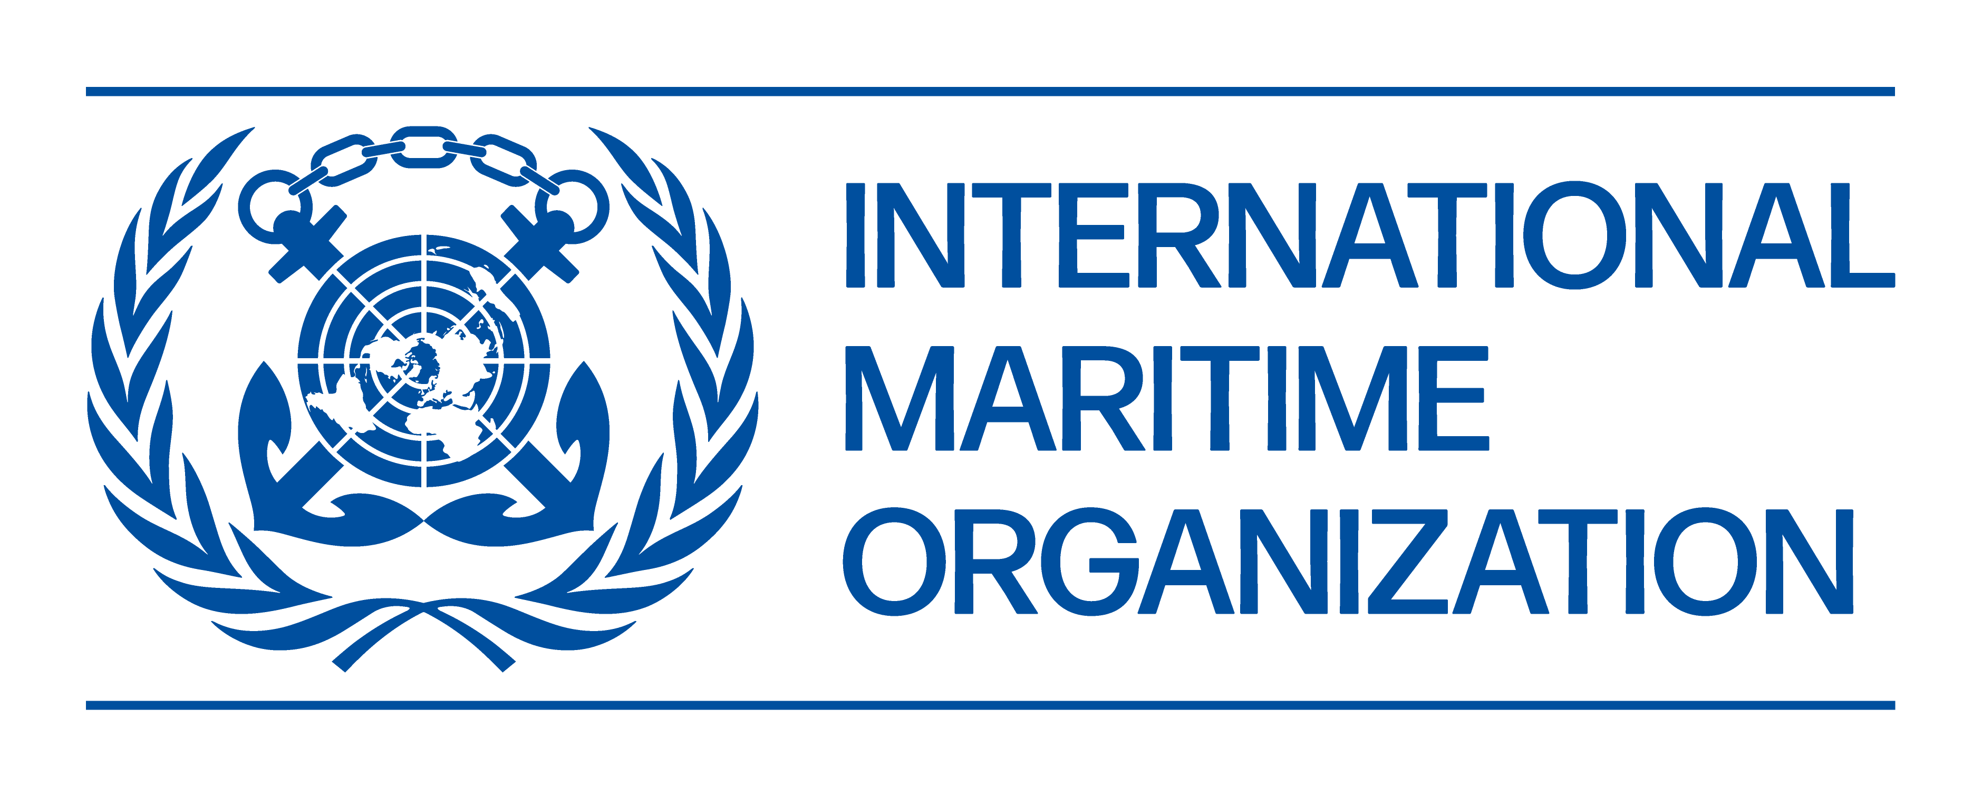
ANNEX 2

Regional Workshop on the promotion of the London Protocol and the Noumea Dumping Protocol. Nadi, Fiji, 25 to 27 March 2026

NOMINATION FORM FOR PARTICIPATION

A completed nomination form, including the acceptance form, should be received by the SPREP not later than Friday, 13 February 2026. Nominations arriving after this deadline will not be accepted.

1 ________________

FAMILY NAME FIRST NAME OTHER NAME

2 Organization
Title/Position in your organization _________________________________________________
Official mailing address

Telephone: _________________________ Fax: _____________________
Work Email: ______________________________ Home Email: ______________________
Mobile: _______________________

3 Nearest airport at which air travel can commence and terminate:
Name of airport __________________ Location __________
4 Date of birth ____________
5 Sex Male _____ Female ____
6 Place of birth ______________
7 Nationality ________________
8 Passport Number_____________
9 Date and Place of Issue ______________________________
10 Person to notify in case of emergency
Name
Address

Telephone: _________________________ Fax: _____________________
Email: ______________________________ Mobile: ______________________

11 Description of your duties

12 Educational background

13 Previous experience

14 Previous relevant training programmes attended

15 If a certificate is to be issued, please print clearly the name as it should appear on the certificate.

______________________
Nominee's signature

Please tick the box to confirm that the nominee meets the profile required for this activity and is the most appropriate candidate.

Each nomination should be submitted in full to:  Dr. Mohammed Asid Zullah  Pollution Adviser  zullahm@sprep.org.  Kindly also copy  Ms. Davina Tiitii  WMPC Programme Assistant  davinat@sprep.org . | ______________________________
Signature of Government official
authenticating this nomination
 | ______________________________
 | Printed name
 | _______________________________
 | Title

***

ACCEPTANCE FORM

I hereby accept the invitation of the International Maritime Organization (IMO) to participate in the Regional Workshop on the promotion of the London Protocol and the Noumea Dumping Protocol, in Nadi, Fiji from 25-27 March 2026, which will be hold with the collaboration of the SPREP.

I confirm that:

1 I will refrain from engaging in political, commercial and any activities other than those governed by the training course/seminar/workshop programme;

2 I have understood the objective, scope and subject areas of the activity as well as its programme;

3 I have noted the profile necessary for the activity and am confident I meet the requirements;

4 I will advise the SPREP immediately if I am unable to attend the training course;

5 I will travel to the venue and return to my home country at the end of the training course, by the route designated by the SPREP;

6 I am prepared to bear the cost of all medical expenses I may incur and am aware that IMO will not assume any relevant responsibility. I understand I am responsible for arranging any necessary insurance cover for my trip;

7 I shall complete and submit the evaluation questionnaire at the end of the event and the ex-post evaluation questionnaire that I will receive at least six (6) months after the completion of the activity; and

8 I am competent in the language to be used in the training course/seminar/workshop.

Signature of Participant _____________________

Name of Participant _____________________
(Printed)

Official address _____________________
_____________________
_____________________
_____________________
_____________________

Date _____________________

___________

